ASSIGNMENT-DAY-02

Linux Commands:

1. **pwd Command**

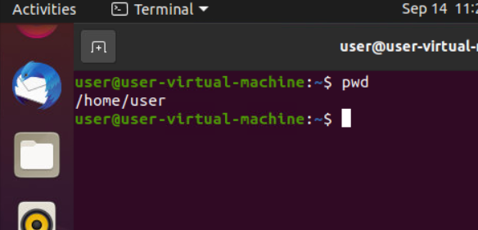

The [pwd](https://www.javatpoint.com/linux-pwd) command is used to display the location of the current working directory.

**2.Clear Command**

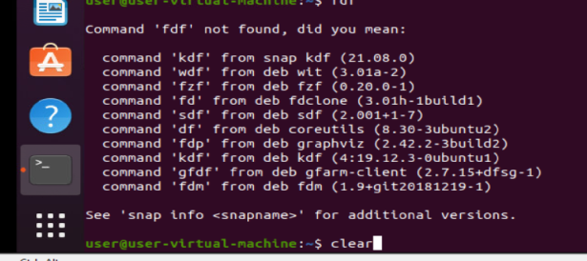 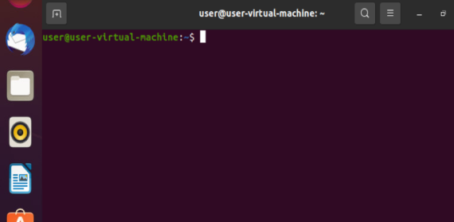

The Clear command is used for to clear all the data in the terminal.

**3. ls Command**

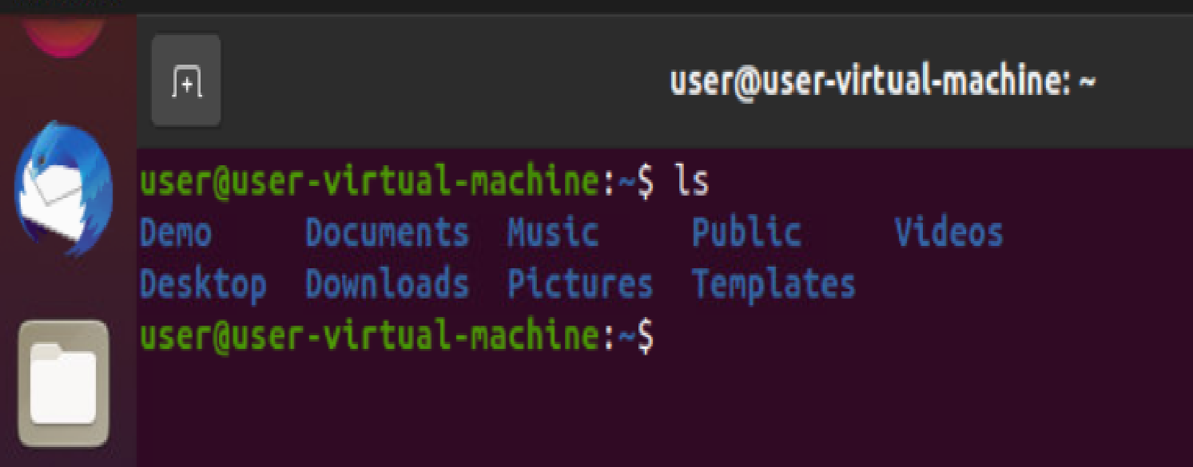

The [ls](https://www.javatpoint.com/linux-ls) command is used to display a list of content of a directory.

**4. ls –l command**

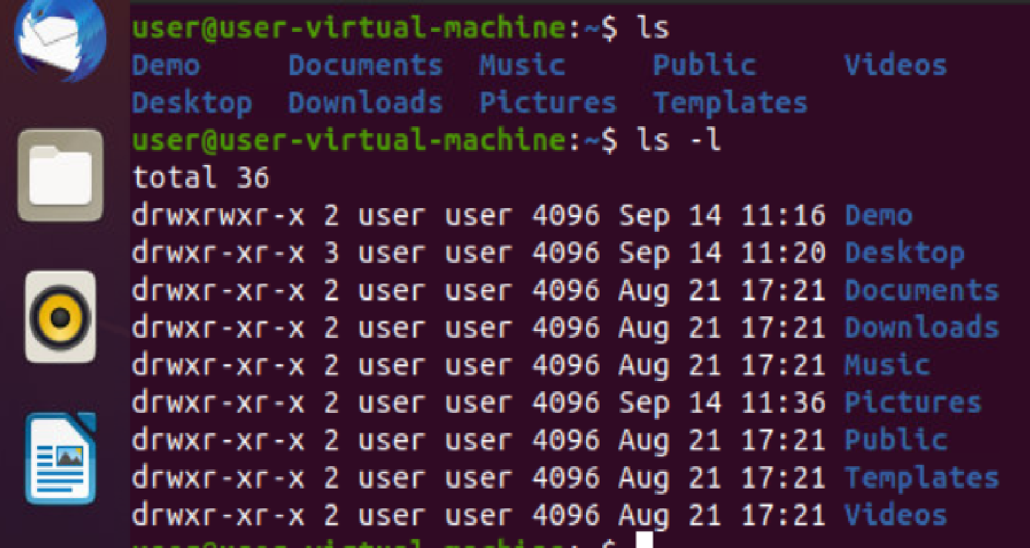

The ls-l command is used to show the all folders in long format.

**5. ls –a command**

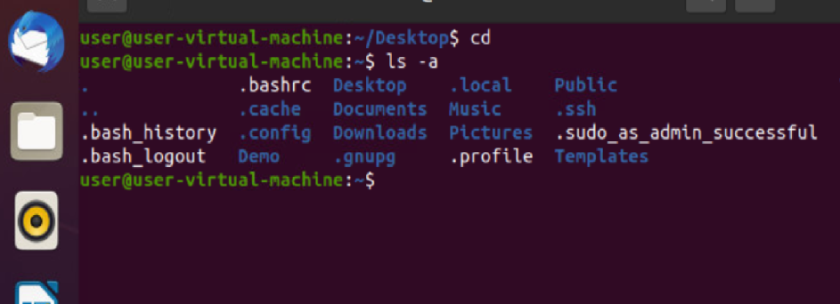

The ls-a command is used to display all folders with hidden folders.

**6. ls –A command**

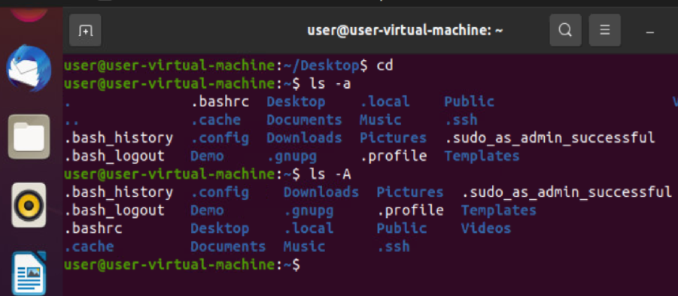

The ls –A command is used to display all folders except hidden folders.

**7. cd Command**

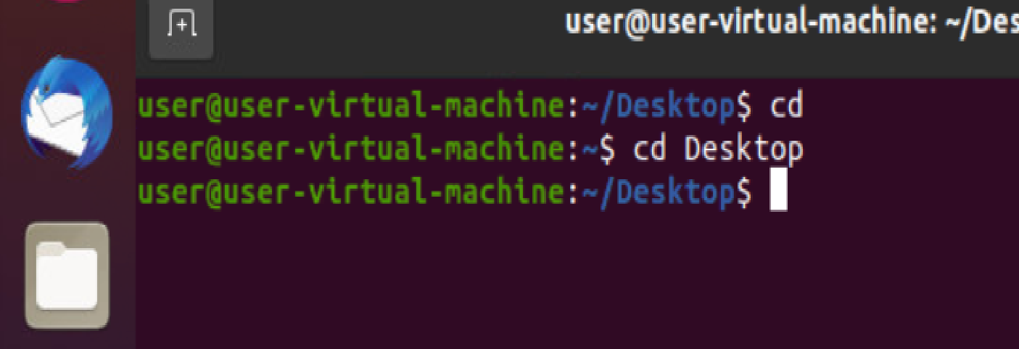

The [cd](https://www.javatpoint.com/linux-cd) command is used to change the current directory.

**8. cd .. command**

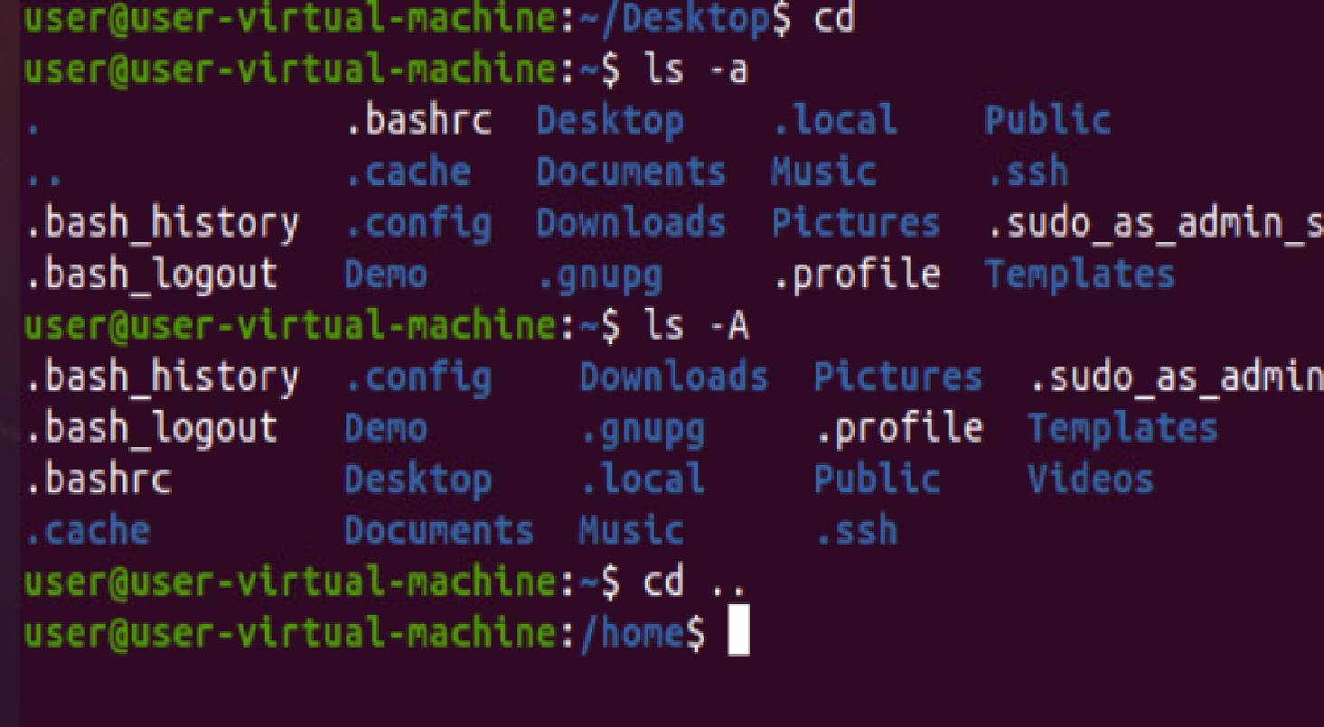

The cd .. command is used to come backward step.

**9. cd / command**

ca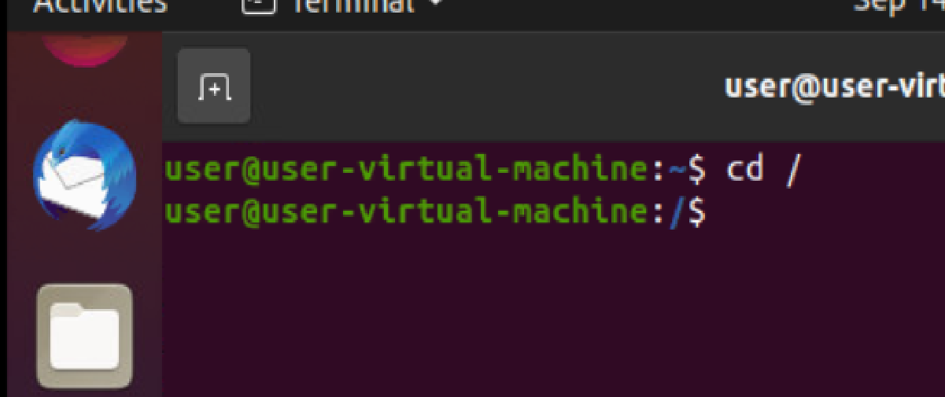

The cd / command is used to move to root directory.

**10.exit command**

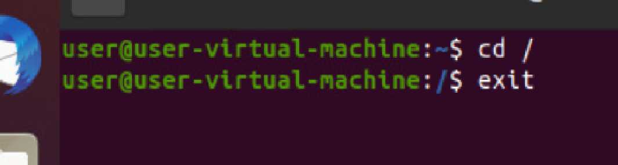

The exit command is used to exit to the terminal.

**11.echo command**

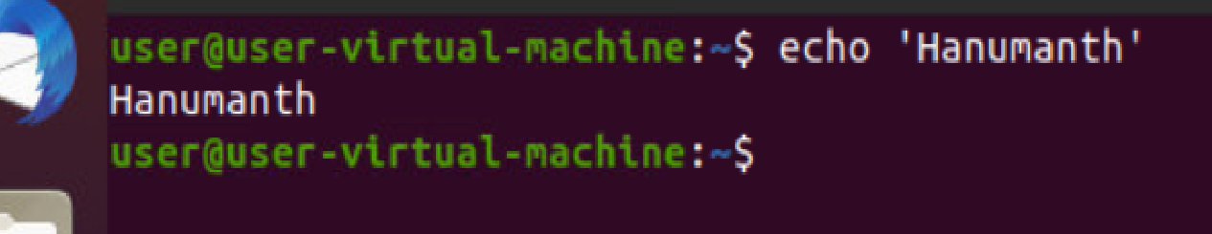

The echo command is used to display.

**12. cat Command**

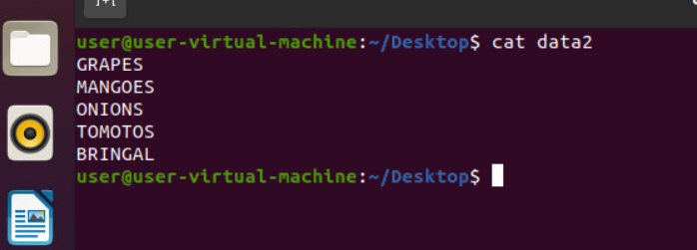

The [cat](https://www.javatpoint.com/linux-cat) command is a multi-purpose utility in the Linux system. It can be used to create a file, display content of the file, copy the content of one file to another file, and more.

13.man command

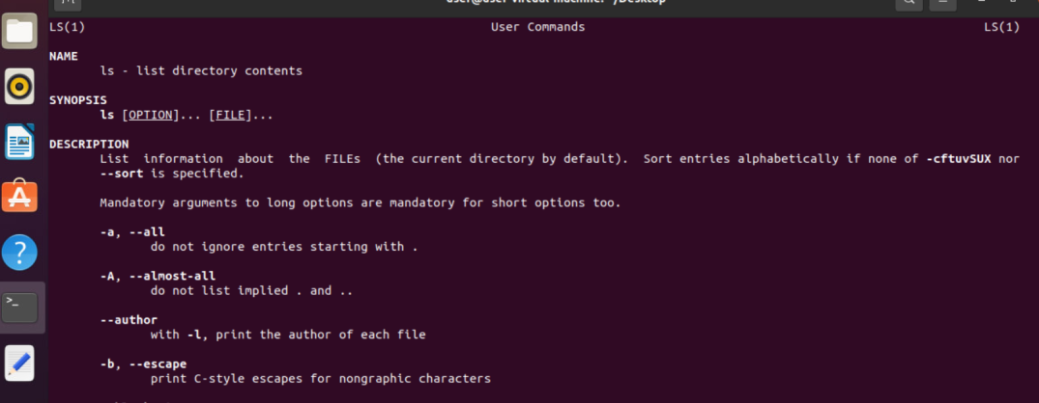

***man*** command in Linux is used to display the user manual of any command that we can run on the terminal.

**14.mv command**

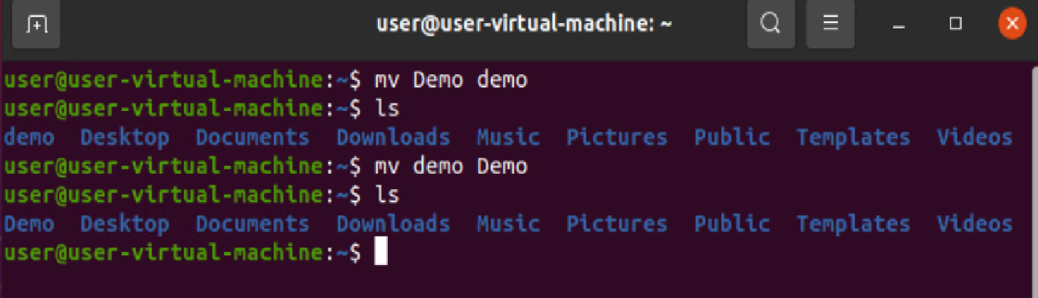

**It changes the directory Name.**

**15.mkdir command**

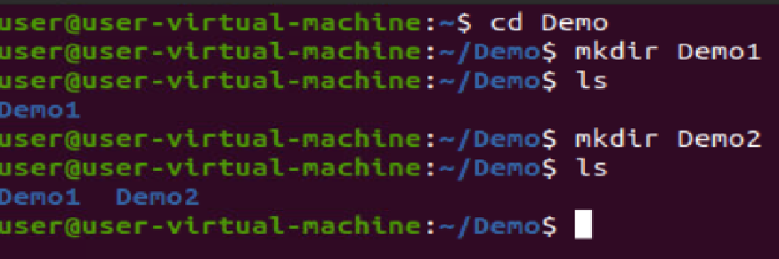

It creates the directory.

**16.rmdir command**

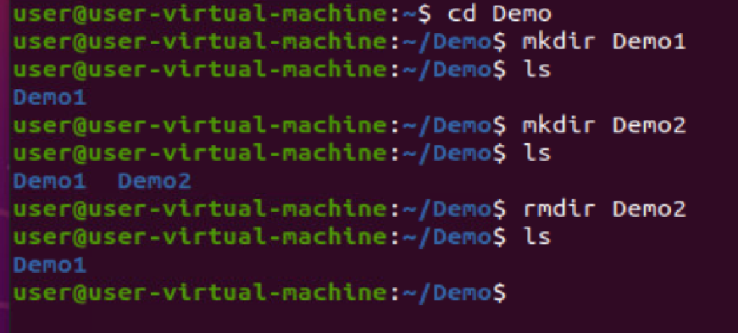

It deletes the directory.

17.who command

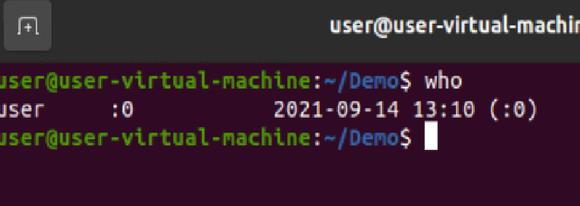

It shows the current version date and time.

**18.date command**

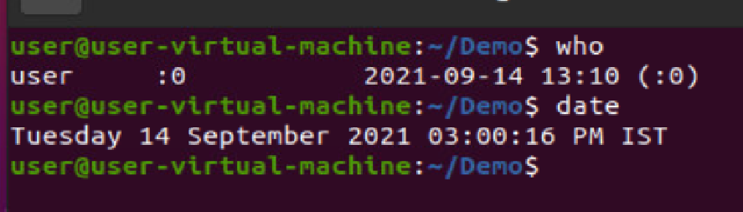

It displays the current date.

**19.cal command**

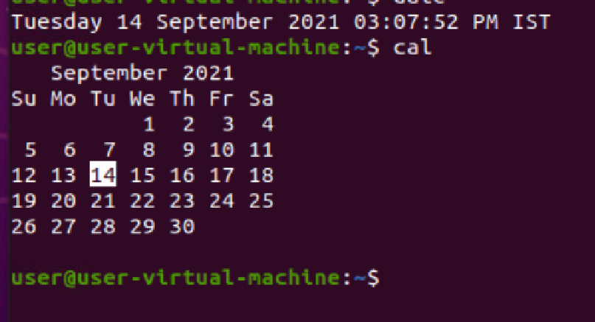

It displays the calendar for current month.

**20.tac command**

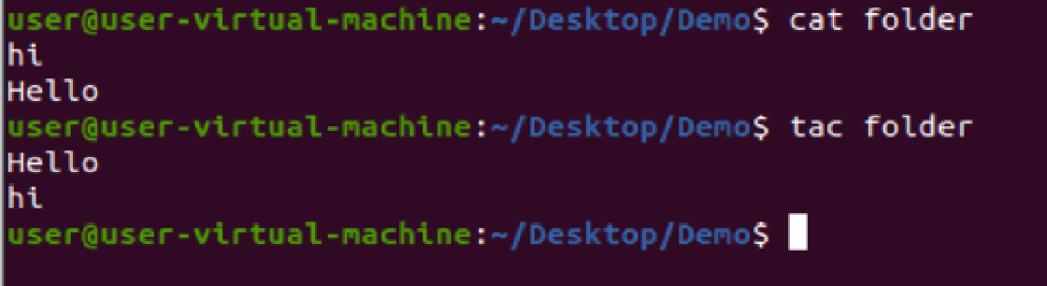

**It is used for reverse order.**

**21.sort command**

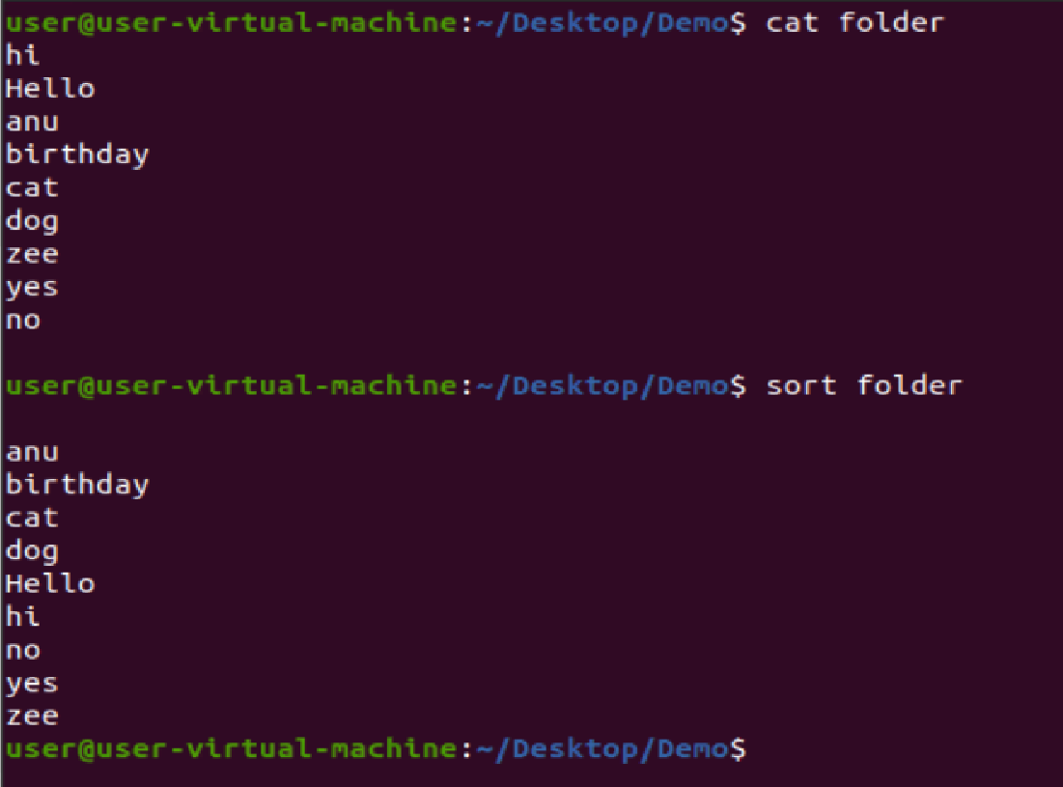

**It is used for sorting the data.**

**22.rm –rf command**

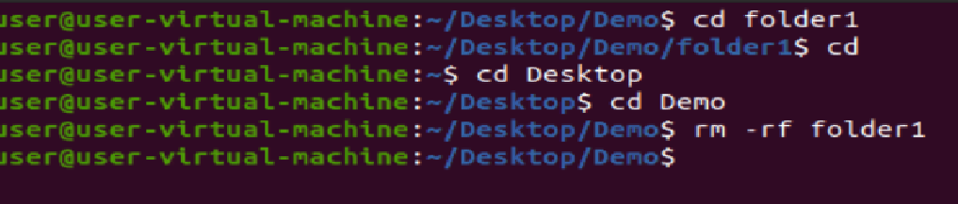

**To delete all the folders at a time.**

**23.passwd command**

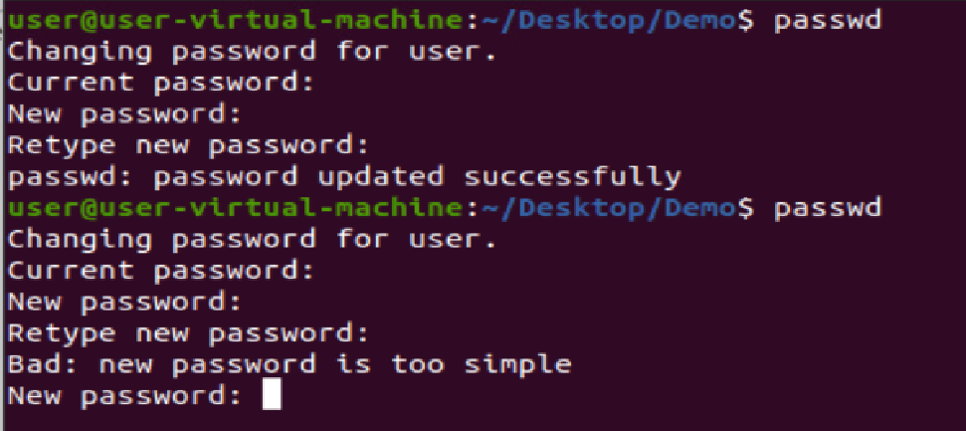

**To change the password of current user.**

**24.tree command**

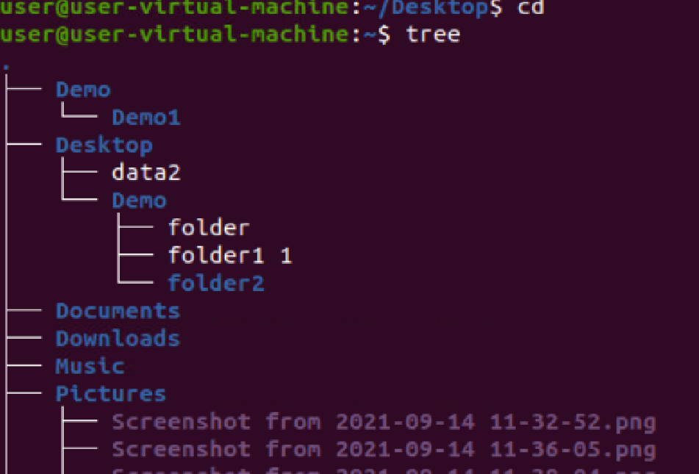

**It describes the tree structure.**

**25.tree –d**

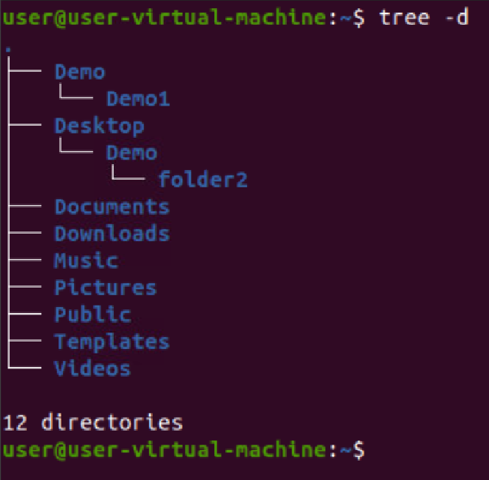

**It shows only directories.**

**26.tree –c command**

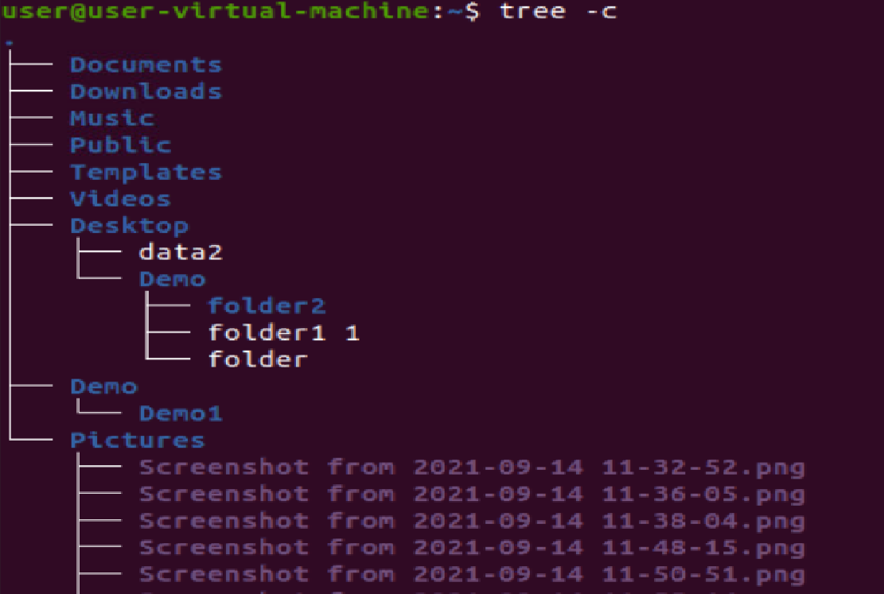

**It displays the directories and folders.**

**27.tree –help command**

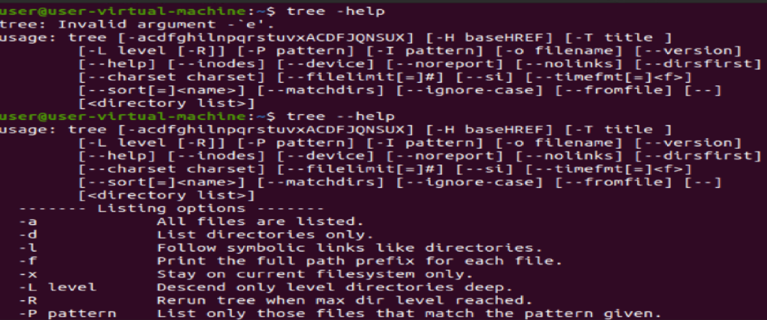

**It displays the description of commands present in tree.**

**28.sudo apt –get update-- It downloads the updates**

**29.sudo apt –get upgrade—It installs the update**

**30.sudo apt –get update && upgrade—it works as download and installation.**

**31.cat command**

**It uses to display the data.**

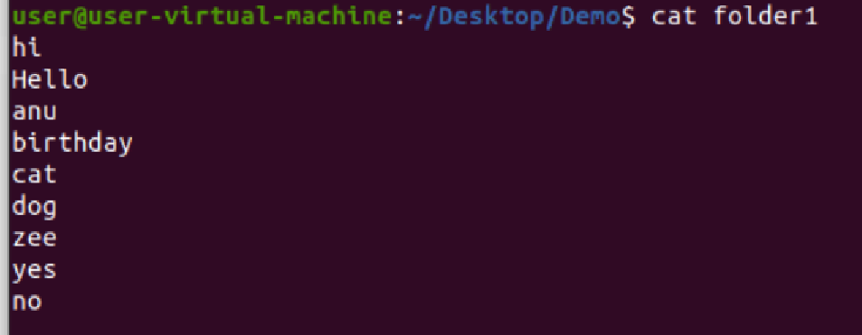

**32.cat folder1>folder**

**It copies the data from one folder to another folder**

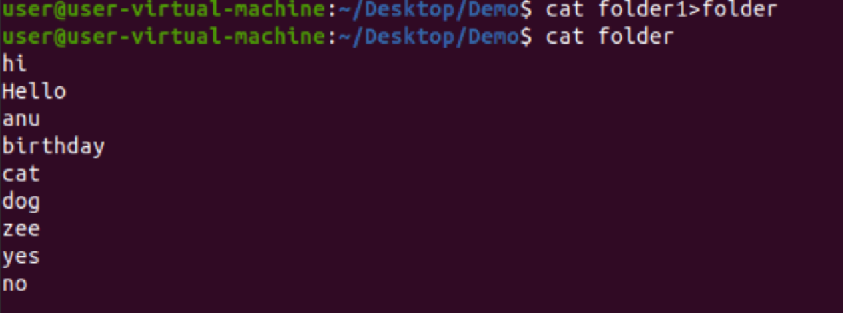

**33.cd/ command**

**It moves to root directory.**

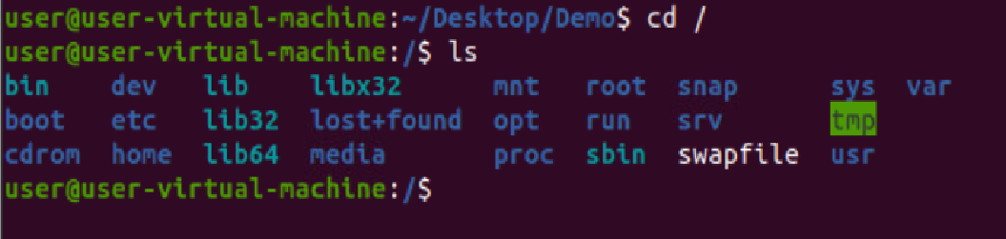

**34.ls –f command**

**It will display all hidden folders without order**

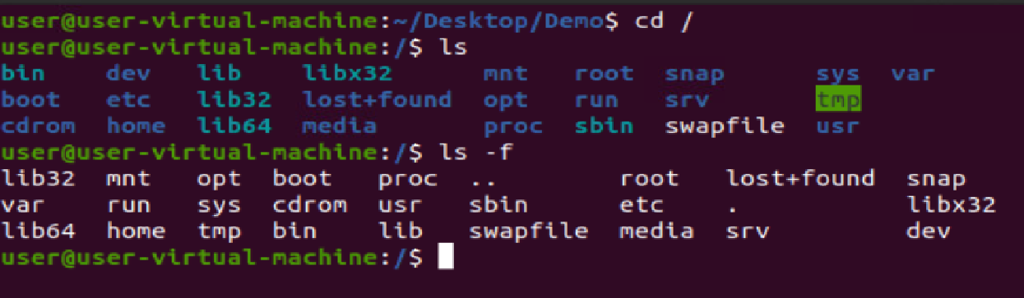

**35.ls –l**

**It describes the folder details.**

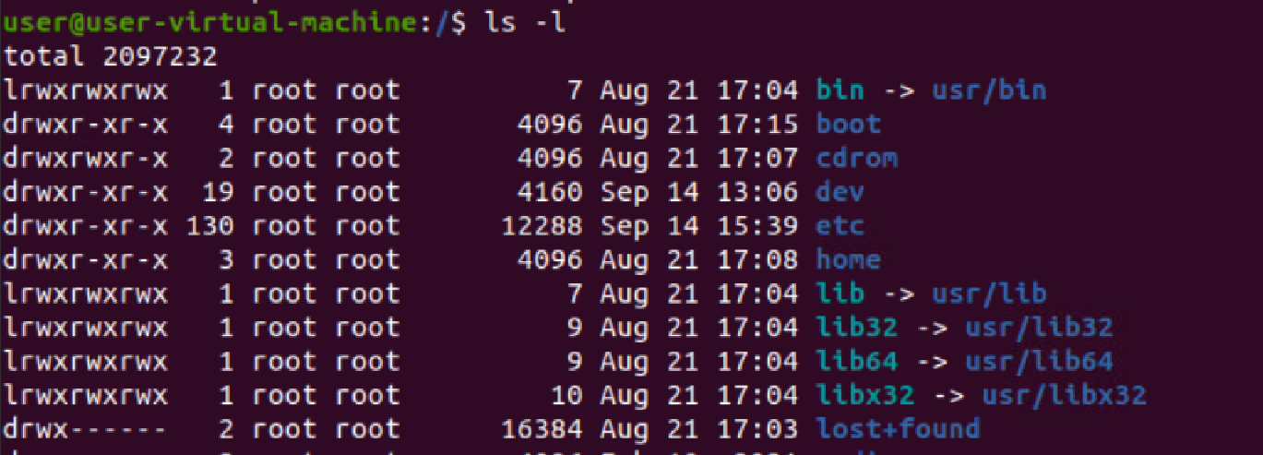

**36.cd**

**Move to home directory.**

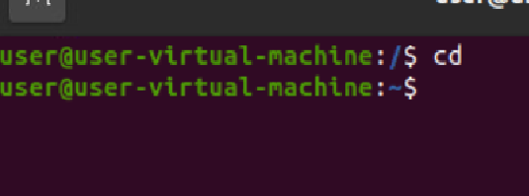

**37.rm command**

**It is used to delete a particular file.**

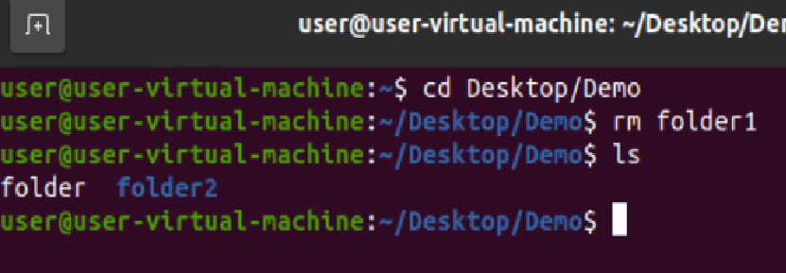

**38.mkdir –p folder2/folder1/1/2**

**Add another folders Inside the folders.**

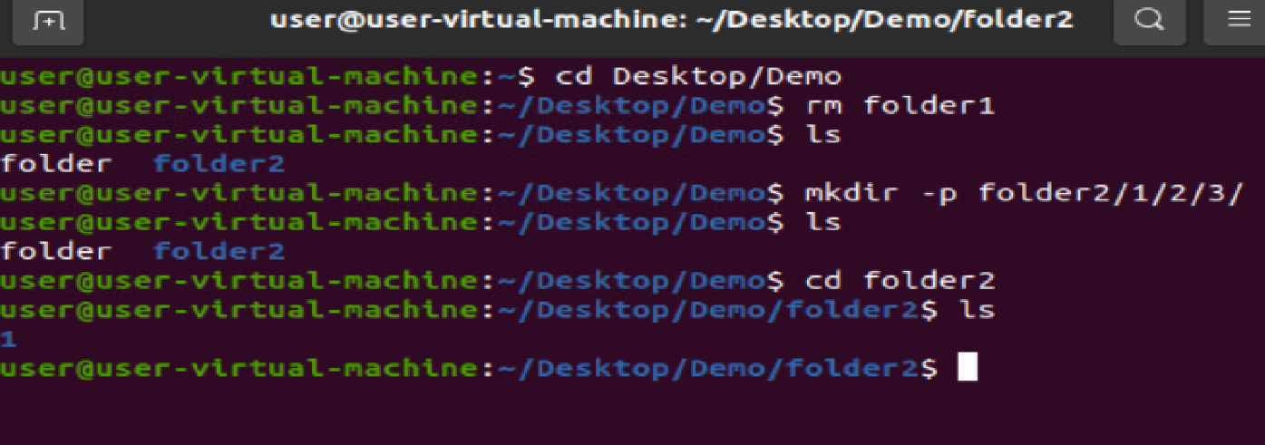

**39.ls –lr**

**To reverse the descriptive format**

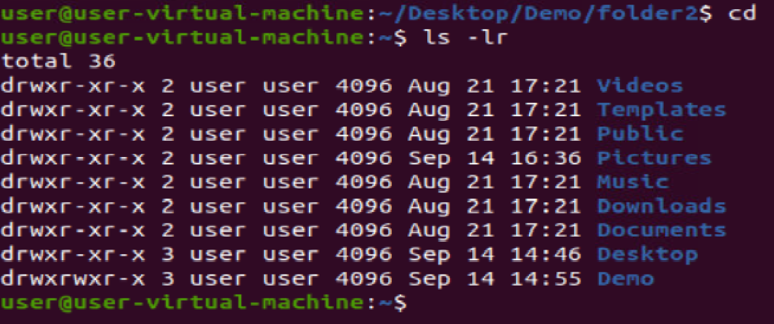

**40.**